**Step 1:**

Log in to TVS-INF-FS1 Server

Then search for Winscp in search box

**Step 2:** Open Winscp

A Dialog Box appears. Enter the credentials and Hostname .

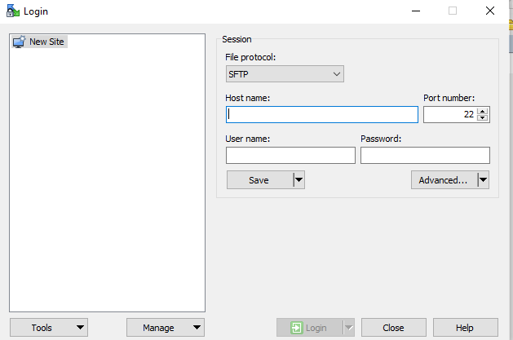

**Step 3:** After Logging in Choose the E Drive Motolog backup folder in left side in Fs1 server and go to home /backups in Right side in Motolog server

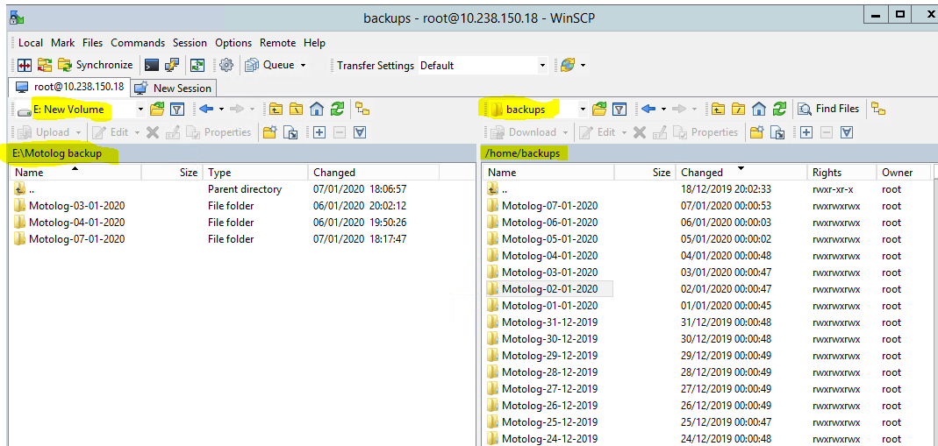

**Step 4:** After that Choose the File from right side in /home/Backups folder and copy paste (or) drag and drop the recent backup file in left side E: folder Motolog backup

**For example** am Moving today backup file (i.e) Jan 7 to the E: folder in Motolog backups. Likewise move the backup file on that particular dates.

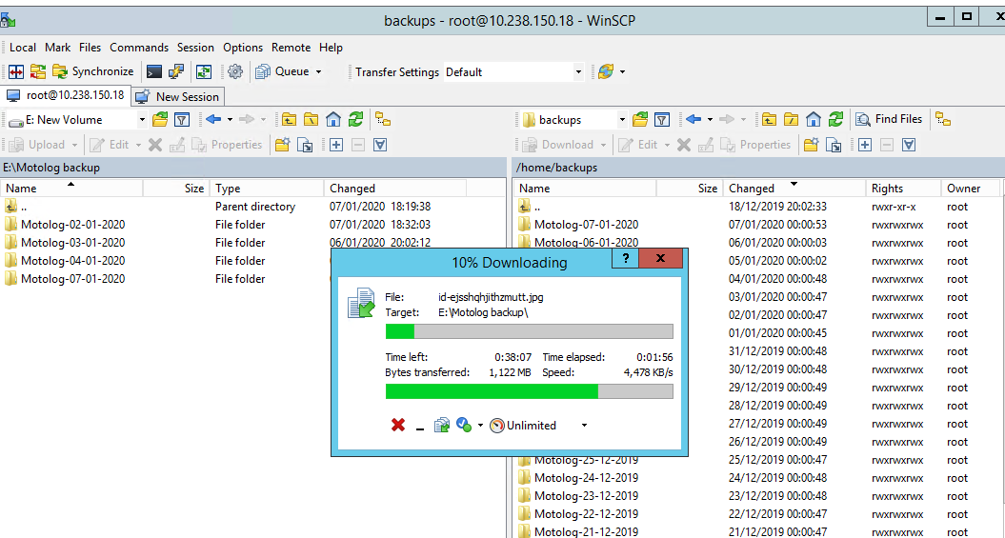

**Step 5:** While moving it shows error give Skip all while error appears.

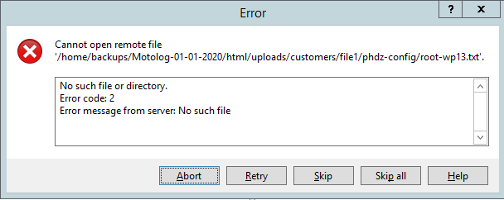

**Step 6:** After Completing the above steps ensure that E Drive Motolog backups has 5 days backup in fs1 server and /home/Backup folder has 1 month backup in motolog server.